Form No. 40-261: For Reporting Year (RY) 2025
Raw Data – Specialist Report Tab
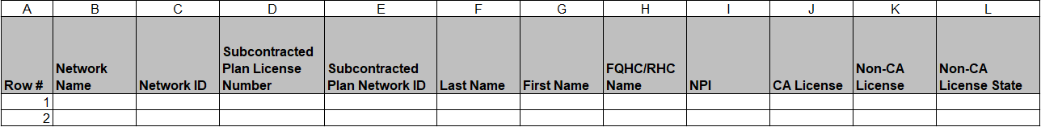
Continuation:
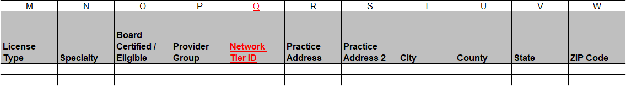
Continuation:
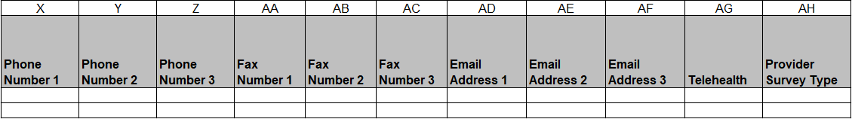
Continuation:
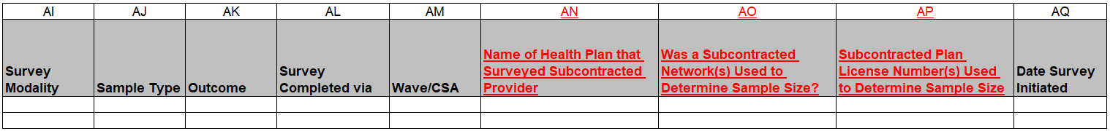
Continuation:
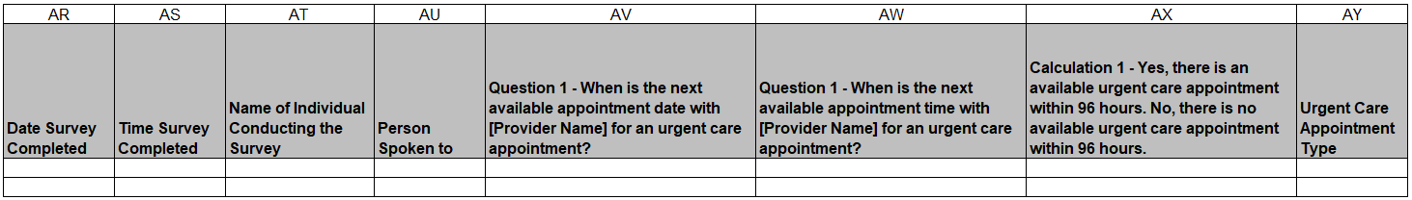
Continuation:
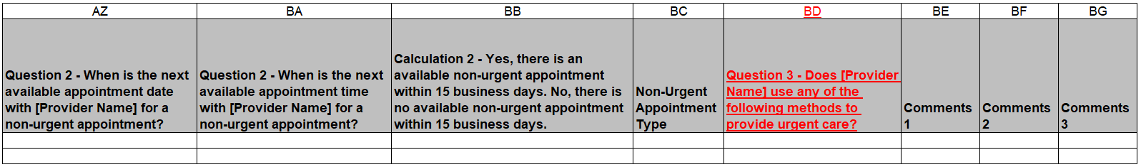

Summary of Changes:
Raw Data – Specialist Report Tab
Excel Column Reference | RY 2025 TA Report Form Heading | Action
Q | Network Tier ID | Added Field and Field Instructions
R | Practice Address | Updated Field Instructions
AN | Name of Health Plan that Surveyed Subcontracted Provider | Added Field and Field Instructions
AO | Was a Subcontracted Network(s) Used to Determine Sample Size? | Added Field and Field Instructions
AP | Subcontracted Plan License Number(s) Used to Determine Sample Size | Added Field and Field Instructions
AY | Urgent Care Appointment Type | Updated Field Instructions
BC | Non-Urgent Appointment Type | Updated Field Instructions
BD | Question 3 – Does [Provider Name] use any of the following methods to provide urgent care? | Added Field and Field Instructions

