Form No. 40-255: For Reporting Year (RY) 2025
Contact List – NPMH Report Tab
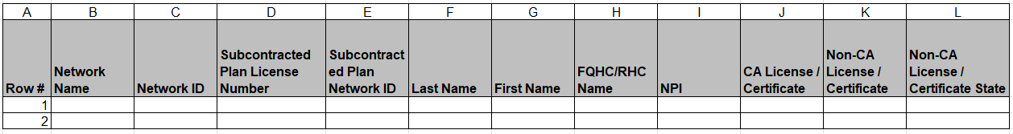
Continuation:
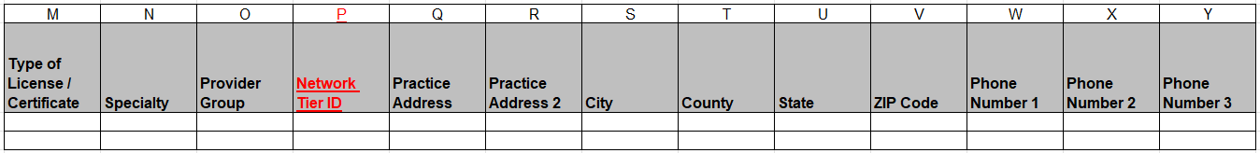
Continuation:
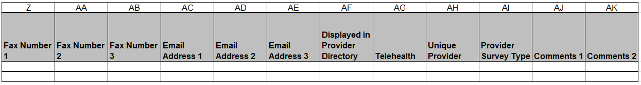
Summary of Changes:
Contact List - NPMH Report Tab
Excel Column Reference | RY 2025 TA Report Form Heading | Action
P | Network Tier ID | Added Field and Field Instructions
Q | Practice Address | Updated Field Instructions

