Form No. 40-270: For Reporting Year (RY) 2024
Hospital Report Tab
Continuation:
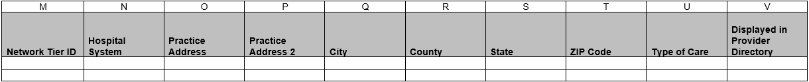

Summary of Changes:
Hospital Report Tab
Excel Column Reference | RY 2024 ANR Report Form Heading | Action
M | Network Tier ID | Updated Field Instructions
U | Type of Care | Updated Field Instructions

Form No. 40-270: For Reporting Year (RY) 2024
Clinic Report Tab
Continuation:

Summary of Changes:
Clinic Report Tab
Excel Column Reference | RY 2024 ANR Report Form Heading | Action
N | Network Tier ID | Updated Field Instructions

