Form No. 40-257: For Reporting Year (RY) 2025
Contact List – Psychiatrists Report Tab
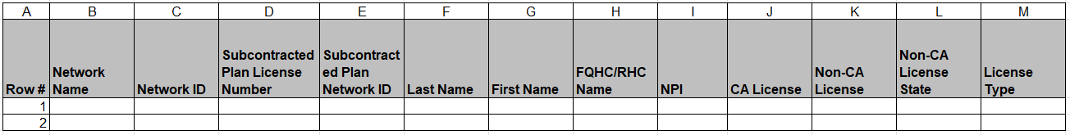
Continuation:
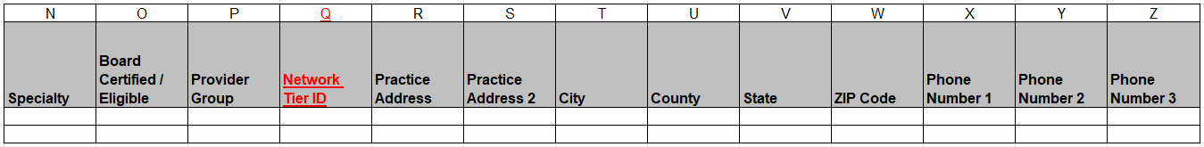
Continuation:
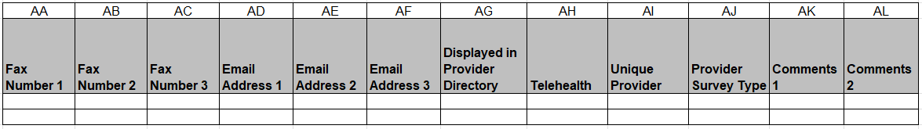

Summary of Changes:
Contact List – Psychiatrists Report Tab
Excel Column Reference | RY 2025 TA Report Form Heading | Action
Q | Network Tier ID | Added Field and Field Instructions
R | Practice Address | Updated Field Instructions

