Form No. 40-259: For Reporting Year (RY) 2025
Raw Data – PCP Report Tab
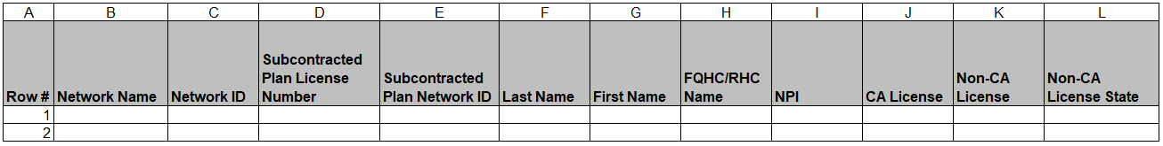
Continuation:
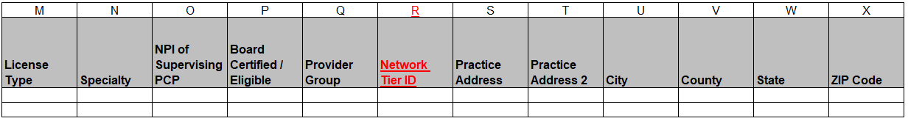
Continuation:
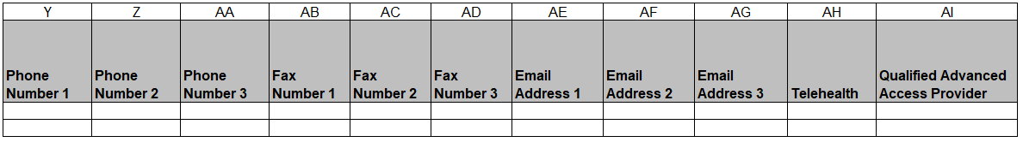

Continuation:
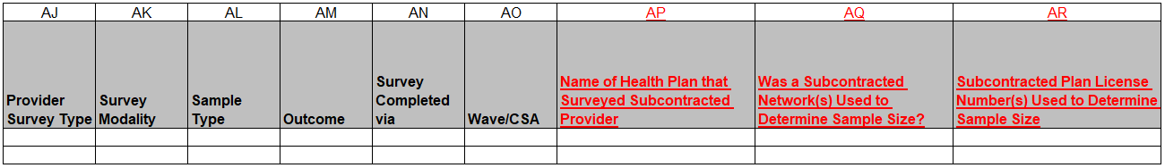
Continuation:
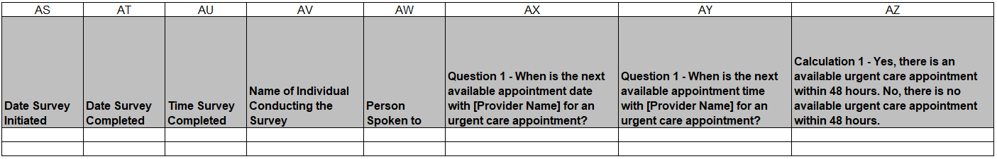
Continuation:
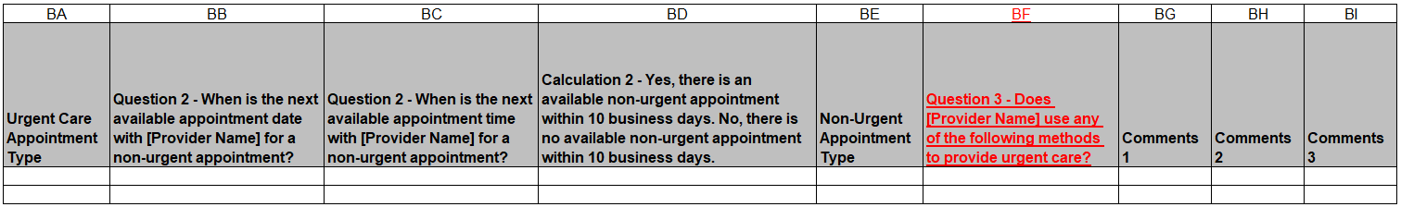
Summary of Changes:
Raw Data – PCP Report Tab
Excel Column Reference | RY 2025 TA Report Form Heading | Action
R | Network Tier ID | Added Field and Field Instructions
S | Practice Address | Updated Field Instructions
AP | Name of Health Plan that Surveyed Subcontracted Provider | Added Field and Field Instructions
AQ | Was a Subcontracted Network(s) Used to Determine Sample Size? | Added Field and Field Instructions
AR | Subcontracted Plan License Number(s) Used to Determine Sample Size | Added Field and Field Instructions
BA | Urgent Care Appointment Type | Updated Field Instructions
BE | Non-Urgent Appointment Type | Updated Field Instructions
BF | Question 3 – Does [Provider Name] use any of the following methods to provide urgent care? | Added Field and Field Instructions

