Form No. 40-273: For Reporting Year (RY) 2024
Out-of-Network Payment Report Tab
Summary of Changes:
No changes to the RY 2024 Out-of-Network Payment Report Tab fields.

Form No. 40-273: For Reporting Year (RY) 2024
Proportion Report Tab
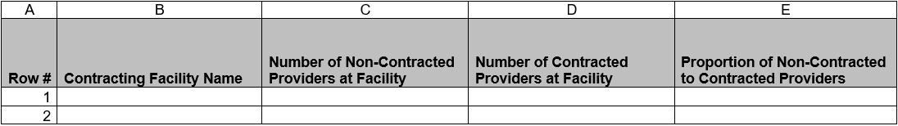
Summary of Changes:
No changes to the RY 2024 Proportion Report Tab fields.

